- Faculty Resources page ( https://www.udc.edu/cal/faculty-resources/
Please correct the verbiage under Blackboard
The new verbiage:
Blackboard is the University of the District of Columbia’s learning management system (LMS). It is available to faculty, students, and staff.
Blackboard link need to land to a new page (Page name : UDC Blackboard)

---------------------------------------------------------------------------------------------------------------New Page- Page name : UDC Blackboard
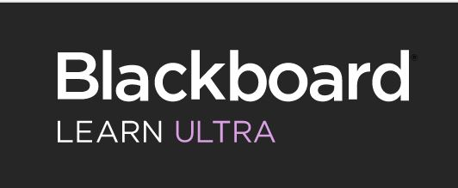
Blackboard Ultra Click here ( Link to The New page for Blackboard Ultra )

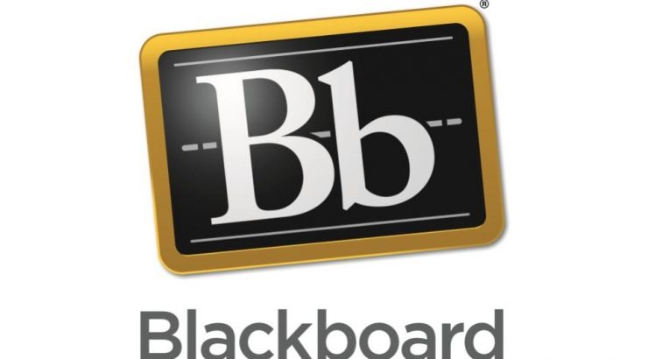

Blackboard Original Click here
Blackboard
Blackboard is the University of the District of Columbia’s Learning Management System (LMS). It is available for faculty, students, and staff. For academic purposes, it is primarily used to facilitate instruction, manage courses (traditional, online, and hybrid), administer assessments, collaborate with students or colleagues using Web 2.0 media and applications, facilitate organizations, and manage assignments. It is a powerful tool for learning. To view UDC’s Blackboard policy, click here.

-----------------------------------------------------------------------------

New page for Blackboard Ultra
Blackboard Ultra Roadmap:
In 2019, the Center for the Advancement of Learning committed to upgrade Blackboard 9.1 to Blackboard Ultra to enhance UDC teaching and learning and to align the Learning Management System with 2022 strategic plan. To upgrade to Blackboard Ultra, UDC Blackboard had to migrate to the cloud-based, Software-as-a-Service (SaaS). In August 2019, UDC Blackboard moved from managed hosting to SaaS. In August 2020, UDC Blackboard will adopt Blackboard Ultra Base Navigation with original course view. An Ultra pilot will run during spring 2021 ​to make sure the transition is as painless as possible. Starting Summer 2021, all UDC courses will be Ultra courses.

Ultra Base Navigation ( Linked to Utra Base Navigation table )
This section focuses on getting you oriented to Blackboard Ultra Base Navigation, and helps you become familiar with the interface.
Building and Modifying Ultra Course ( Linked to Building and Modifying Ultra Course table)
This section will help you understand the Blackboard Ultra course layout and add, modify, and edit content.
Communication Tools ( Linked to Communication Tools, Blackboard Collaborate, Webex tables )
This section explores the built-in communication tools in Blackboard, e.g., Messages and Announcement.
Assessing Learners (Linked to Assessing Learners table )
This section explores two types of assessment tools in Blackboard: the assignment and test tools, which are essential in assessing student progress and providing feedback to learners.
Gradebook (Linked to Graebook table )
This section will discuss the main elements of Gradebook in Blackboard Ultra, which helps faculty monitor learner progress and manage class assignments and attendance.
Blackboard Instructor App
Blackboard Instructor is a mobile app that enables faculty to view course content, modify settings, grade assignments, connect with students in discussions, and launch Blackboard Collaborate sessions.

Ultra Base Navigation (Page)

This section focuses on getting you oriented to Blackboard Ultra Base Navigation, and helps you become familiar with the interface.

Ultra Base Navigation Overview | Watch
Edit Your Profile in Blackboard Ultra | Watch
Modifying Notification Settings | Watch
Connecting Blackboard with Cloud Storage Accounts | Watch
Activity Stream Overview | Watch
Courses | Watch
Organizations | Watch
Calendar | Watch
Messages | Watch

Building and Modifying Ultra Courses (Page)

This section will help you understand the Blackboard Ultra course layout and add, modify, and edit content.

Ultra Course Interface Overview | Watch
Adding Content to Course Content Area | Watch
Creating a Learning Module | Watch
Creating a Document Page | Watch
Creating a Link in the Course Content Area | Watch
Creating a Link Using the Content Editor | Watch
Copy Content | Watch
Import Content | Watch
Managing Items | Watch
Content Editor | Watch
Conditional Availability | Watch
Student Preview Tool | Watch

Communication Tools ( Page)

This section explores the built-in communication tools in Blackboard, e.g., Messages and Announcement.

Create Announcements | Watch
Course Messages | Watch
Create a Discussion | Watch
Discussions Analytics | Watch
Creating a Journal | Watch
Add a Journal Entry | Watch

Blackboard Collaborate
Blackboard Collaborate Overview | Watch
Accessing Blackboard Collaborate | Watch
Whiteboard | Watch
Sharing an Application or a Desktop | Watch
Sharing Files | Watch
Sharing PowerPoint Files | Watch
Breakout Groups | Watch
Share Files to Breakout Groups | Watch
Polling | Watch
Live Closed Captioning | Watch
Session Settings | Watch
Attendee Management | Watch

Webex Meeting - Virtual Meetings
Accessing & Setting up your Webex Account | Watch
Schedule Virtual Meeting Using Webex | Watch

Assessing Learners ( Page)

This section explores two types of assessment tools in Blackboard: the assignment and test tools, which are essential in assessing student progress and providing feedback to learners.

Creating Assignments | Watch
Using SafeAssign | Watch
Viewing & Grading Assignments | Watch
Annotating Submissions | Watch
Download Submissions | Watch
Creating a Test | Watch
Create Matching Questions | Watch
Fill in the Blank Question | Watch
Reuse Questions | Watch
Using Question Pools | Watch
Timed Tests | Watch
Create Rubrics | Watch
Associate Rubrics | Watch
Grade Using a Rubric | Watch
Conditional Availability | Watch
Assessment Exception | Watch
Accommodations | Watch

Gradebook ( Page)

This section will discuss the main elements of Gradebook in Blackboard Ultra, which helps faculty monitor learner progress and manage class assignments and attendance.

Gradebook Overview | Watch
Overall Course Grade | Watch
Accessing the Submissions Page | Watch
Submissions Page Layout Overview | Watch
Feedback Recording | Watch
Attendance Overview | Watch
Adding a Row in Gradebook | Watch

